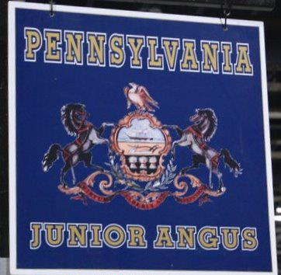
2015 SEMEN SALE
Friday March 27th, 2015
Following the PA Finest Female Sale
At the Penn State Bull test Center
Offering Semen from the following bulls:
AAR Ten X 7008 SA PVF Insight 0129
BCA Flawless Quaker Hill Rampage 0A36
Leachman Saugahatchee 3000C VAR Index 3282
SAV Classified 3427 RB Tour Of Duty 177
Connealy Final Product SAV Resource 1441
Connealy Final Solution Dameron Second Chance
EXAR Blue Chip 1877B Coleman Charlo 0256
Dameron First Impression Connealy Black Granite

Benefits Pennsylvania Junior Angus Association
Fundraising Committee for the
2016 Eastern Regional Junior Angus Show - Harrisburg, PA
For more information contact..
Caleb Schmuck - 814-289-7932
Matthew Mitchell - 484-332-3965
Cherry Knoll Total Product

